Inkjet Design Notes

Oliver Kesterton - September 2015

# Introduction

This page aims to summarise my findings from about 8 weeks of experiments aiming to produce a piezo driven inkjet. This would be useful, as it would potentially allow for the 3D printing of a wide range of materials, such as waxes and low temperature melting point metals. The latest working design is shown in the image below. A reservoir is connected to the inkjet via a feed tube, and there is another tube to allow air to easily escape.

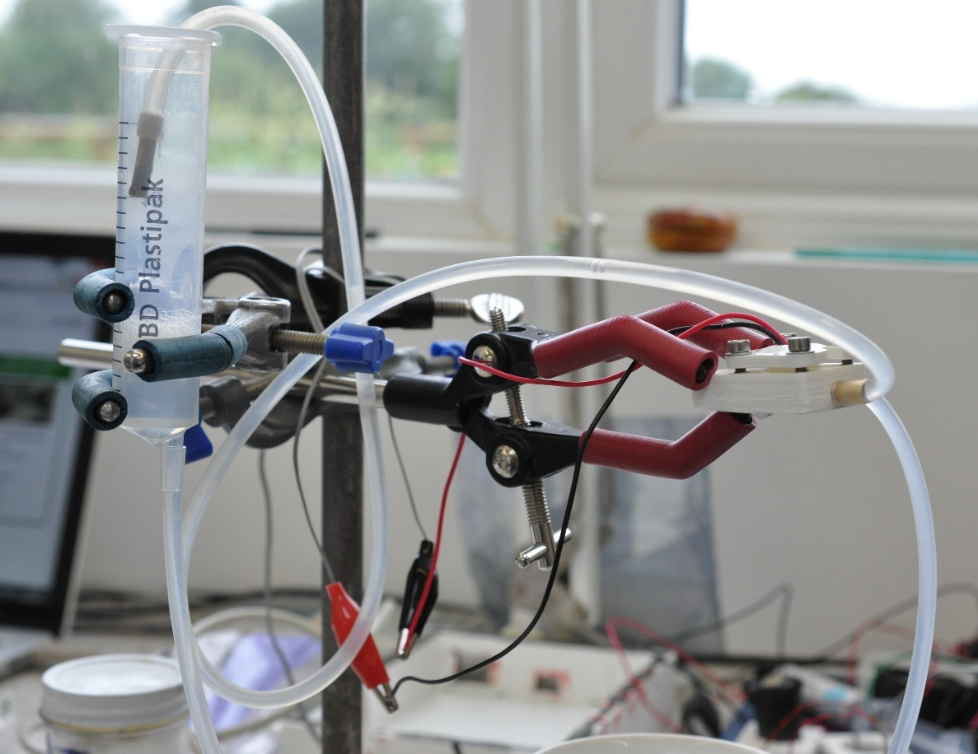

## Other inkjet designs

A number of other inkjet designs have been made by members of the Reprap community:

<http://reprap.org/wiki/Scratchbuilt_Piezo_Printhead>

<http://reprap.org/wiki/Reprappable-inkjet> (The starting point for this series of experiments)

<http://reprap.org/wiki/Heated_Piezo_for_Jetting_Wax>

# Piezo Discs

All of the piezo inkjet designs tested have been based on piezo buzzer discs. These are generally designed as small speakers/sounders, driven from low voltage sources. However, if the driving voltage is increased to about 100V, these discs deflect by a large enough amount that they can be used as a driver in an inkjet.

Two different sized piezo discs have been tried: 12mm and 27mm, and both have been made to work. However, it seems easier to get an inkjet based on a 27mm inkjet to function, most likely due to its larger movement when actuated. However, it would be more desirable to use a 12mm disc, as it allows the whole inkjet unit to be smaller. The 12mm designs tested seem more sensitive to the nozzle design, and to air in the chamber, but can be made to work well.

An important consideration is the polarity of the piezo disc. The actuating pulse should actuate the disc so that fluid is ‘kicked’ out of the nozzle, and the disc should then retract draw more fluid into the chamber.

# Nozzle Design

The design of the nozzle seems to be critical in the performance of the inkjet. It seems that various factors such as nozzle diameter, thickness and shape affect whether the inkjet will do nothing, smoothly jet, or pool outside the nozzle.

A number of different designs of nozzle have been tried:

### Hot Glue nozzle

The first inkjet tested was essentially a copy of this (<http://reprap.org/wiki/Reprappable-inkjet>) inkjet, and used the nozzle design discussed on that page. This involved putting a blob of hot glue over a needle, and carefully shaving off slices using a sharp knife until a small hole formed. I had some success with this nozzle, but it was quite unreliable. Fluid sometimes jetted, but sometimes pooled outside the nozzle. Manufacturing multiple nozzle consistently was also difficult.

### Aluminium tape

This method used a needle to poke a hole in a piece of aluminium tape, which was then taped over the hole. Very little success was had, and fluid tended to pool outside the nozzle. The nozzle diameter was difficult to control, and the edge was quite ragged, which probably didn’t promote smooth flow. The smallest diameter achieved was about 0.1mm, which seemed too large for an inkjet using water.

### Cannibalised ink cartridge nozzle

The HP51604A inkjet, which had been used for other tests, has a plate with twelve (approximately) 50 micron diameter holes[1]. This was easily extracted from the inkjet with a scalpel. This plate was then taped onto the front disc of the reprap inkjet using aluminium tape, carefully covering all but one of the holes. This produced reasonable results, but there was a tendency for water to pool just outside the nozzle in the rectangle formed by the tape. An improvement was to use araldite to cover all but one hole, putting the tape further from the nozzle, but performance was still not great, and it was not consistent.

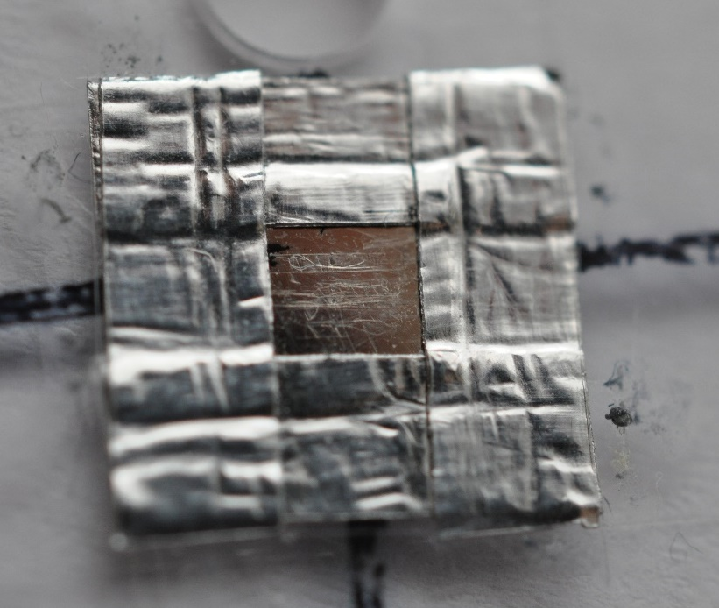

### Mesh and Araldite nozzle

The most successful nozzle design has been with a 61 micron nickel mesh, intended for use in filtration systems. Discs were laser cut out, and they taped onto the inkjet front using aluminium tape. Araldite was then carefully applied, under a microscope, covering almost all of the holes. A varying number were left uncovered. Most success seemed to come from leaving four holes uncovered. It seems that the way this nozzle works is for water to pool outside the nozzle slightly, in the dimple made by the araldite, and they form a single droplet when actuated (i.e. this nozzle does not spray four separate jets). It seems the dimple must be round and uninterrupted, or the nozzle will not work reliably:

The nozzle on the left did not work, whereas the on one on the right did. The one of the left has a groove/notch running away from the nozzle, which may have drawn fluid away, preventing it from working.

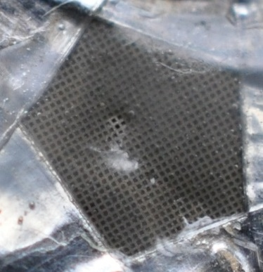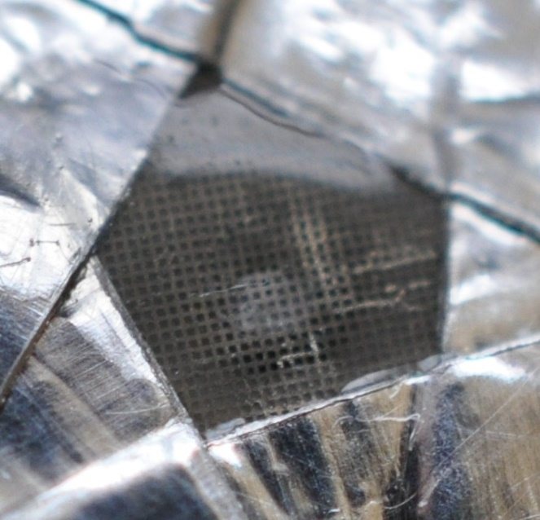

For the heated inkjet, JB weld was used instead of araldite, and this worked just as well.

### Future

None of the nozzle designs produced so far have been ideal. All are slightly temperamental at best. An ideal nozzle may perhaps be a simple clean, round hole in a thin sheet of metal (or perhaps kapton/polyimide if the inkjet is to be used with liquid metals). The ideal hole diameter for water seems to be about 50 microns, but this may well be different for other fluids.

# Chamber Pressure

The inkjet was fed from a reservoir consisting of a syringe (without plunger), which allowed the surface level to be varied. This meant that the chamber pressure could be precisely controlled, and it seems to have a big effect on whether the inkjet will work or not. If the pressure is too high, fluid will ooze out of the nozzle. Too low, and no fluid will be ejected when the inkjet is actuated.

For water, the ideal level seems to be between 0 and 5mm H20 in the chamber. I.e. the reservoir surface should be level with, or up to 5mm above the level of the nozzle. Note that air bubbles in the feed line will affect this, so should be avoided.

# Driving Electronics

All testing of the piezo inkjet has been done using the Piezodrive PDU100b, which uses a TI DRV8662 piezo driver IC. Work has begun on making a dedicated PCB using this IC, details of which are in the RepRapPro Inkjet Github repository.

## Pulse Shape

Various frequencies and pulse lengths have been tested, and seem to have varying results. Most testing has been done with 100V square waves. More research in this area would be good, to determine accurately what effect different frequencies, mark times, and space times have on the jetting performance. It may be that there is an ideal frequency where the driving frequency matches the natural frequency of the oscillating fluid, increasing jet amplitude.

Good performance seems to come from a pulse train consisting of 200 microsecond pulses and 2ms spaces, but various other pulse trains also work.

Some experimenting was done by adding a diode in series with the piezo disc, and a resistor in parallel with the piezo disc (which acts as a capacitor). This has the effect of slowing the retracting of the disc after each pulse, but it seemed to have no effect on the jet performance.

# Heating

Some efforts have been done into heating the inkjet. This has been done by casting the inkjet in a high temperature resin (Alchemix EP 425), and inserting a heater cartridge (as used on the Ormerod hot end) into a hole. This has allowed the inkjet to be heated to about 60 degrees C, although heating is not uniform. The resin is not at all thermally conductive, so the area near the heater approaches 150 C (resulting in burn marks near this area), whereas the other end is only at 60. Perhaps milling the inkjet out of metal would be preferable, although this is undesirable as it prevents liquid metals being used in the inkjet.

A heated inkjet will require the reservoir and any feed tubes to also be heated. During testing, this was achieved by wrapping nichrome wire around the tube and reservoir and then covering with kapton tape. The wire was simply connected to a power supply. Changing the voltage (and therefore the current) allowed temperature to be controlled. An IR thermometer is useful to have, as it allows you to quickly check temperatures.

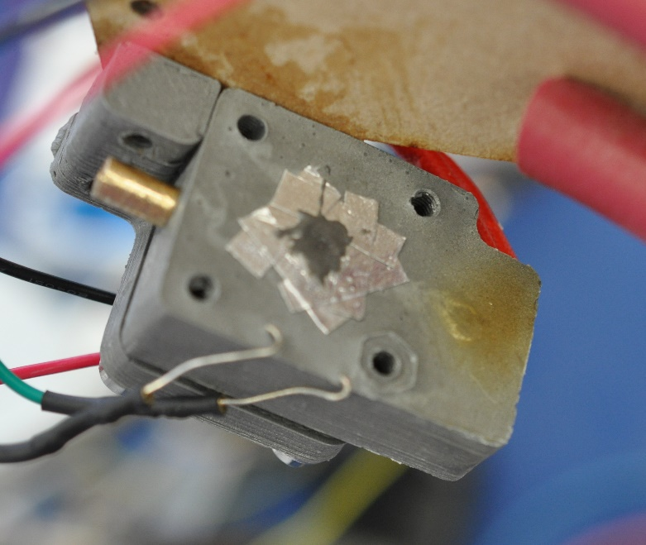

# Fluids

Most of the inkjet testing was done with water, with a few drops of detergent (washing up liquid) added to reduce the surface tension. Water is convenient, as it is readily available, works at room temperature, and doesn’t stain. In theory, it should have similar properties with ink. Some experiments were done with water with a few drops of printer ink added to colour it, to provide colour.

A very limited amount of testing (only about one day) has been done with polyethylene glycol (PEG) wax, which melts at around 50 degrees C. Initial testing simply heated up a reservoir and feed tube with nichrome wire, and heated the inkjet with a cartridge heater driven by Ormerod electronics. The wax melted, but could not be made to jet out of the nozzle (the same nozzle had worked well with water). Air in the chamber does not seem to be the problem (the chamber was allowed to cool, solidifying the wax, and air bubbles did not appear to be present). My hunch is that the nozzle needs to be optimised for the wax, which has a very different viscosity from water. A wax inkjet that has worked (<http://reprap.org/wiki/Heated_Piezo_for_Jetting_Wax>) used a larger diameter nozzle (250 micron compared to four 61 micron holes on my inkjet), so this may be an area to explore.

1. Note that older versions of the HP51604 have a more complex, slightly 3D plate with extra holes. This is harder to use, so it you plan to experiment with this nozzle technique, try and obtain a recently manufactured 51604 cartridge.